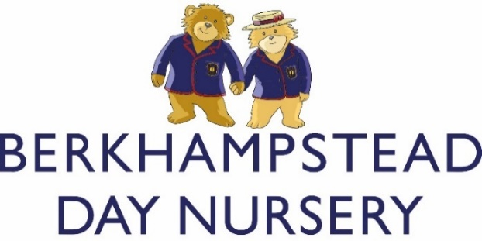

ANTI_BULLYING POLICY

Here at Berkhampstead Day Nursery, we believe that bullying is any repeated action taken by one or more persons with the deliberate intention of causing hurt to another person either physically or emotionally. Whilst most of the children in our care are very young and may not understand their actions, we do all we can to prevent bullying by promoting a nursery ethos which values equality and diversity (see Equal Opportunities Policy). It is made clear through our policies and general practice that any form of bullying (including Homophobic, Cyber, Transgender, Racist, Gypsy, Roma and Traveller etc) connected to the Day Nursery is not acceptable.

We will treat all allegations of bullying seriously and will endeavour to establish all the facts surrounding the incident. If deemed necessary, age-appropriate action will be taken in order to prevent further incidents from occurring; these actions may include one-to-one supervision and a Positive Plan being implemented. In line with our Behaviour Policy, we will support children in a way which is appropriate for their age and stage of development in understanding why their behaviour is not acceptable and help them to understand the consequences of their actions.

At the Day Nursery, we believe that adults have a duty of responsibility to act as positive role models for children. All staff recognise the influence their actions can have on children’s behaviour and a respectful and polite nature is expected at all times. By promoting a culture in which all children feel safe, loved and valued, bullying is far less likely to occur.

If you have any concerns about your child being bullied, then please notify your child’s key person or a member of the Nursery management team immediately.

Policy reviewed – March 2021
Policy to be next reviewed – March 2022 – Acting Day Nursery Manager

