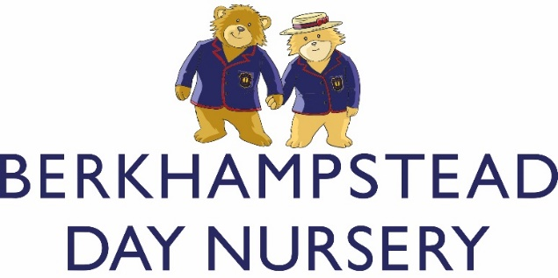

ADMISSIONS POLICY

Berkhampstead Day Nursery welcomes children from the age of 3 months to 4 years and 11 months and is open Monday - Friday from 8am - 6pm, year round.
We currently support the Government’s Early Years Funding Schemes.

The Entry Procedure

Berkhampstead Day Nursery will ask for your child to attend a ‘settling in session’ to assess if both you and your child will be happy at the Nursery. All ‘settling-in’ sessions are free and individually tailored to the needs of your child. You’ll get a warm welcome from the staff and a big smile from the other children. We are very flexible and will ensure that you and your child are happy.

Registration

Berkhampstead Nursery asks for a deposit upon registration to hold a place for your child to join the Nursery. The deposit is equivalent to one month’s fee and 50% is refundable when your child joins the Nursery; the other 50% is refundable when your child leaves the Nursery. You are also required to pay £50 registration fee which is non-refundable.

Birth Certificate

A copy of your child’s birth certificate will be required by the Nursery when registration forms are completed. A medical form for your child must also be completed prior to joining the Nursery.

Special Needs

We do not discriminate in any way regarding entry. We welcome children with special educational needs, providing that the Nursery can offer them the support that they require. We welcome children with physical disabilities provided that our site is suitable for them. However, we advise parents of children with special educational needs or physical disabilities to discuss their child’s requirements with the Nursery.

We will discuss thoroughly with parents and their medical advisers the adjustments that can reasonably be made for the child if he/she joins the Day Nursery.

Sibling Policy

Most siblings join us at the Nursery. However, admission is not automatic, and it is recommended that the sibling is registered as soon as possible in order to ensure a place is available. Second and third siblings at the Nursery are entitled to 5% discount of the fee. This is calculated net of any other discount already applied.

Religious Beliefs

Although Berkhampstead Day Nursery has Christian roots, we do not select for entry on the basis of religious belief.

Equal Treatment

Berkhampstead Day Nursery’s aim is to encourage applications from parents with as diverse a range of backgrounds as possible. This enriches our community and is vital in preparing our pupils for today's world.

Berkhampstead Day Nursery is committed to equal treatment for all, regardless of a candidate's race, ethnicity, religion, disability, sexual orientation or social background.

Contractual Terms and Conditions

Copies are on the Nursery’s web site and will be made available to parents as part of the admissions process.

Entry in to Berkhampstead School

Entry to Kindergarten or Reception is not automatic or guaranteed. Parents are advised to register for the School as early as possible to avoid disappointment.

Complaints

We hope that you and your child do not have any complaints about our admissions process; copies of the Nursery’s complaints procedure can be sent to you on request. It is also on the Nursery website.

Policy reviewed – March 2021
Policy to be next reviewed – March 2022 – Acting Day Nursery Manager

